ContactManagement_Verify Contact notes _Instance44_12-Jul-2018_02-59-02_AM_SingleSignOn.png

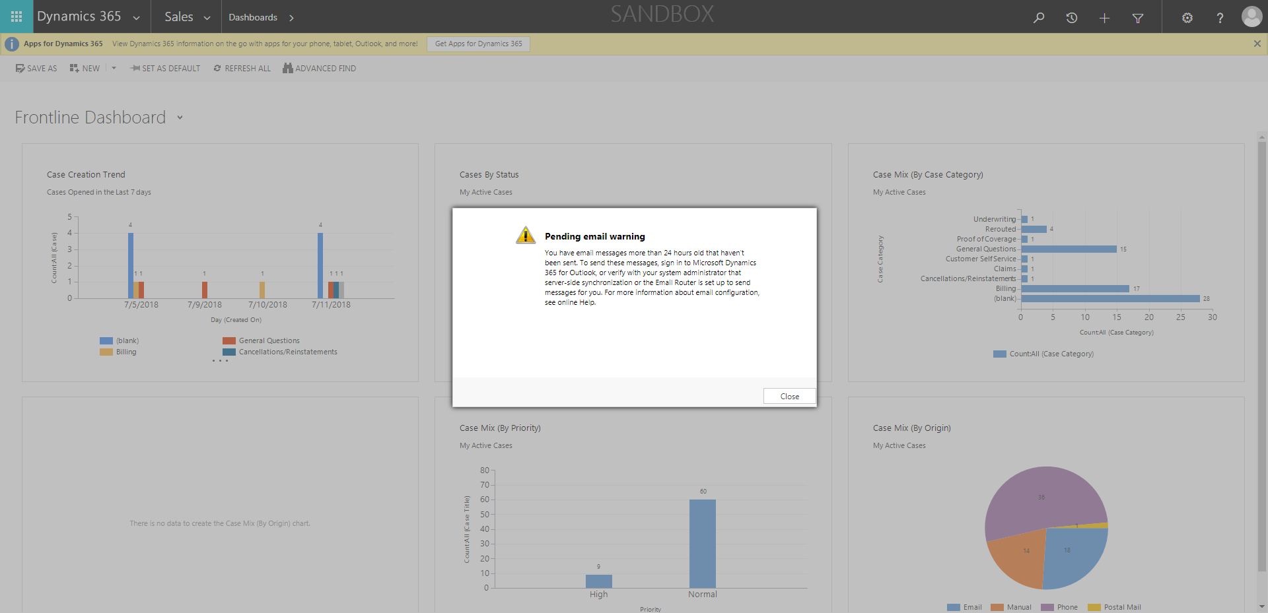

ContactManagement_Verify Contact notes _Instance44_12-Jul-2018_02-59-25_AM_Validatingcontactentitynavigation.png

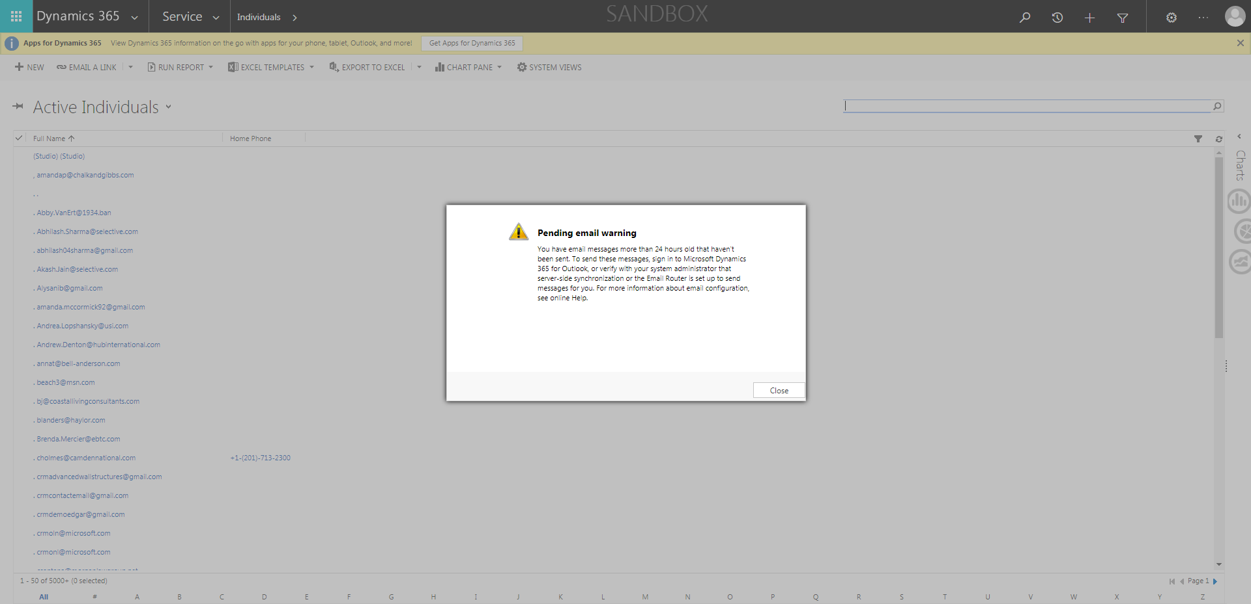

ContactManagement_Verify Contact notes _Instance44_12-Jul-2018_02-59-35_AM_VerifyingAllNotesofanindividual.png

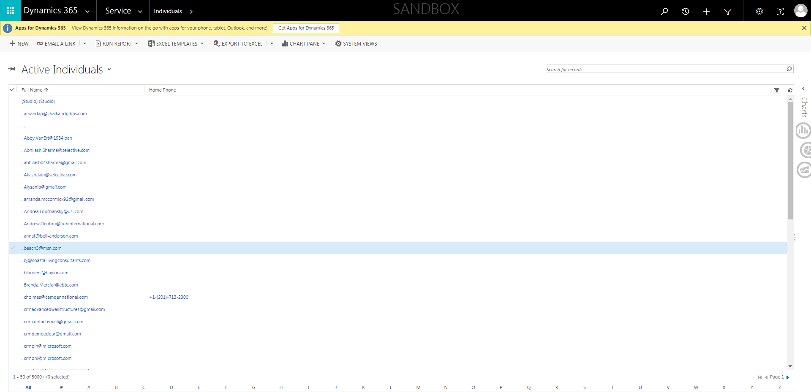

ContactManagement_Verify Contact notes _Instance44_12-Jul-2018_02-58-46_AM_MouseClickActiononStaleElement.png



ContactManagement_Verify Contact notes _Instance44_12-Jul-2018_02-59-06_AM_SingleSignOn.png

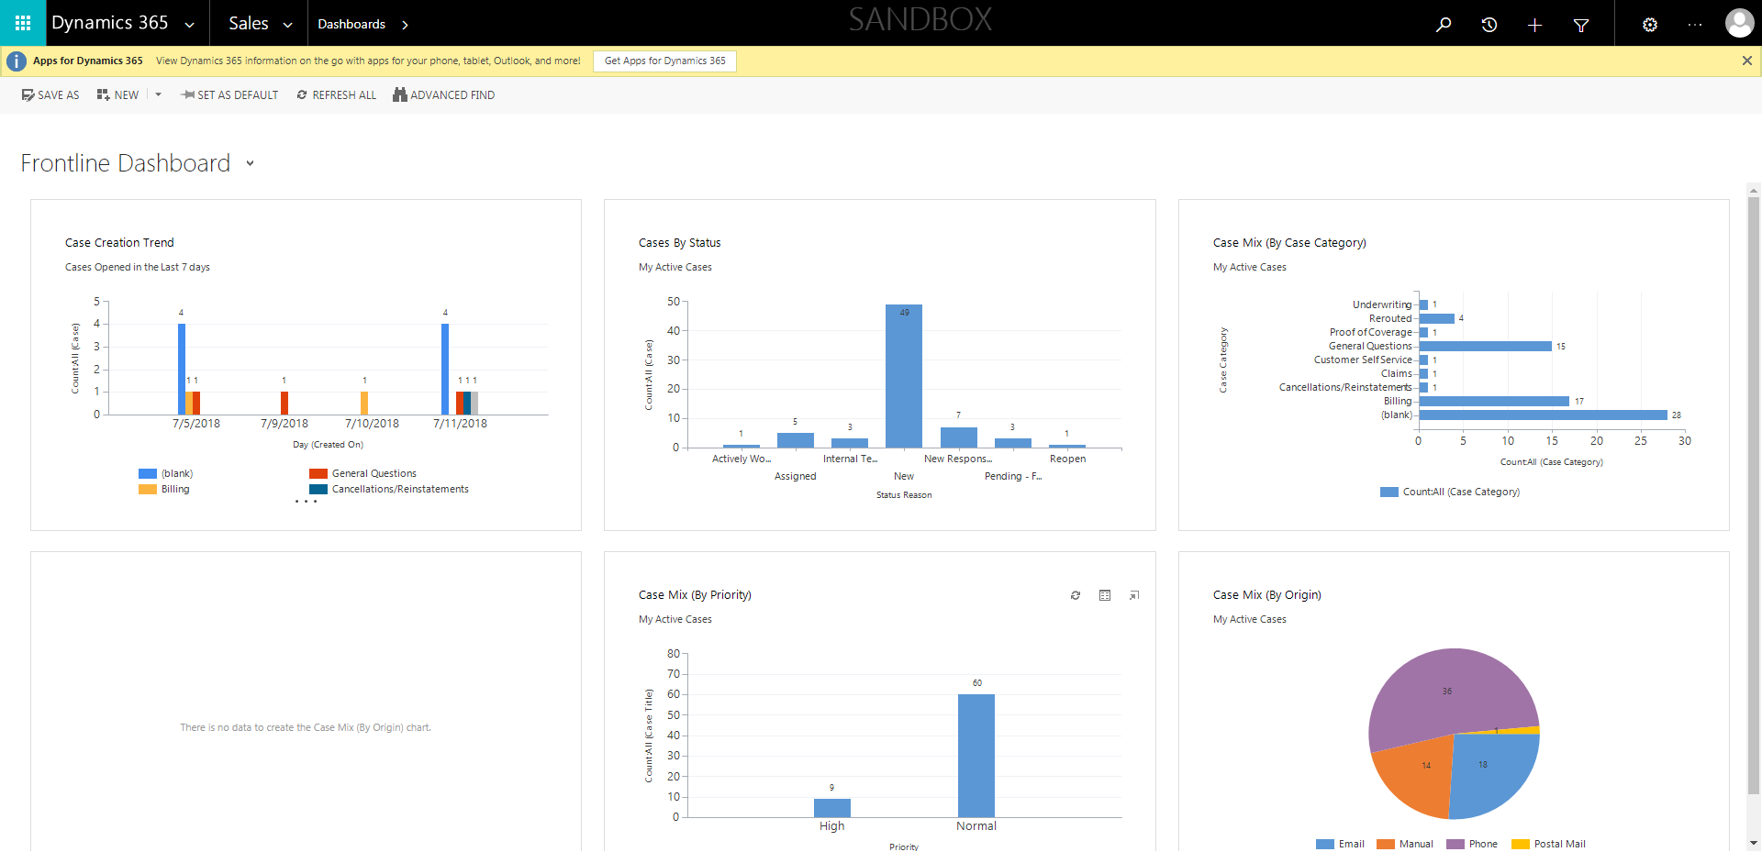

ContactManagement_Verify Contact notes _Instance44_12-Jul-2018_02-58-48_AM_EnterTextAction.png

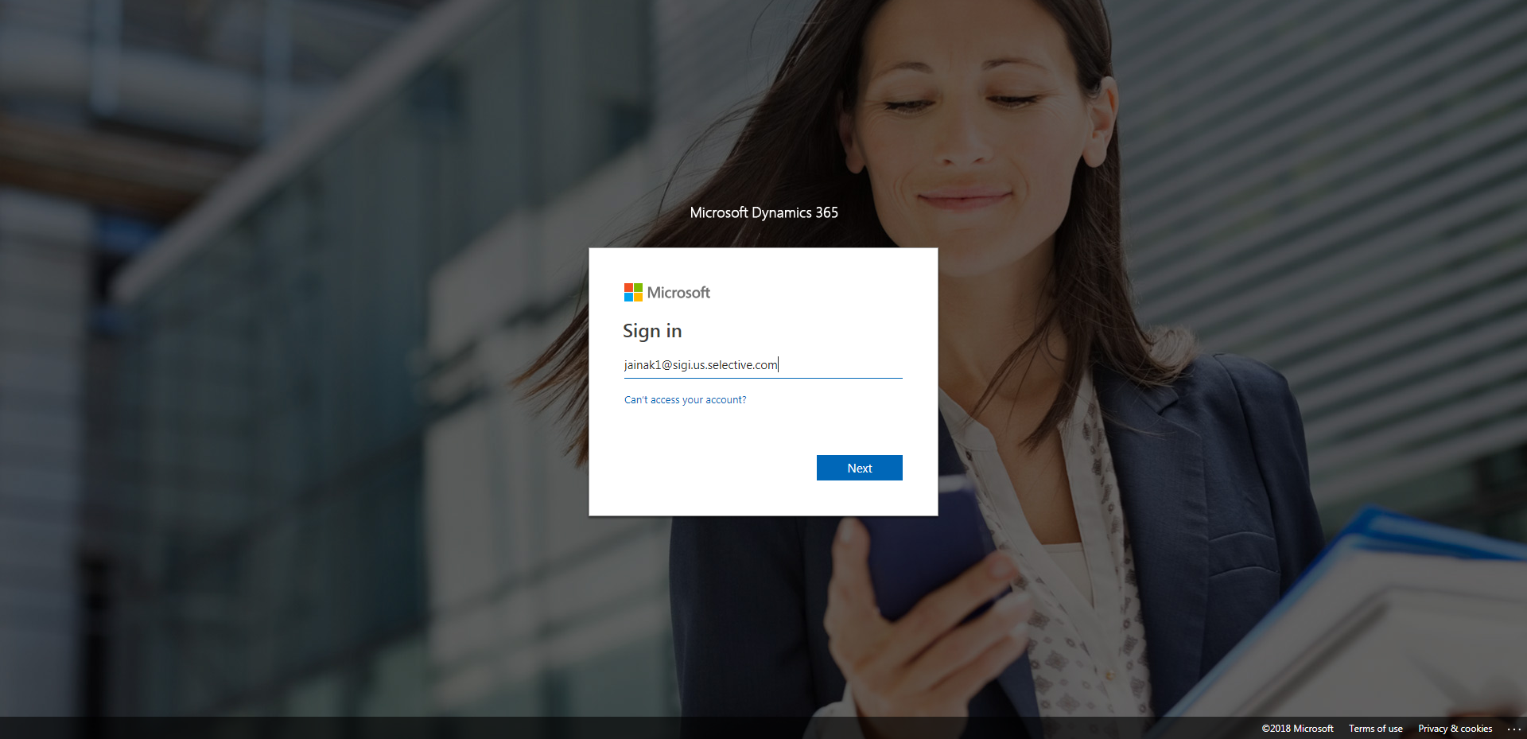

ContactManagement_Verify Contact notes _Instance44_12-Jul-2018_02-58-49_AM_MouseClickActiononStaleElement.png

